**Assignment** -1

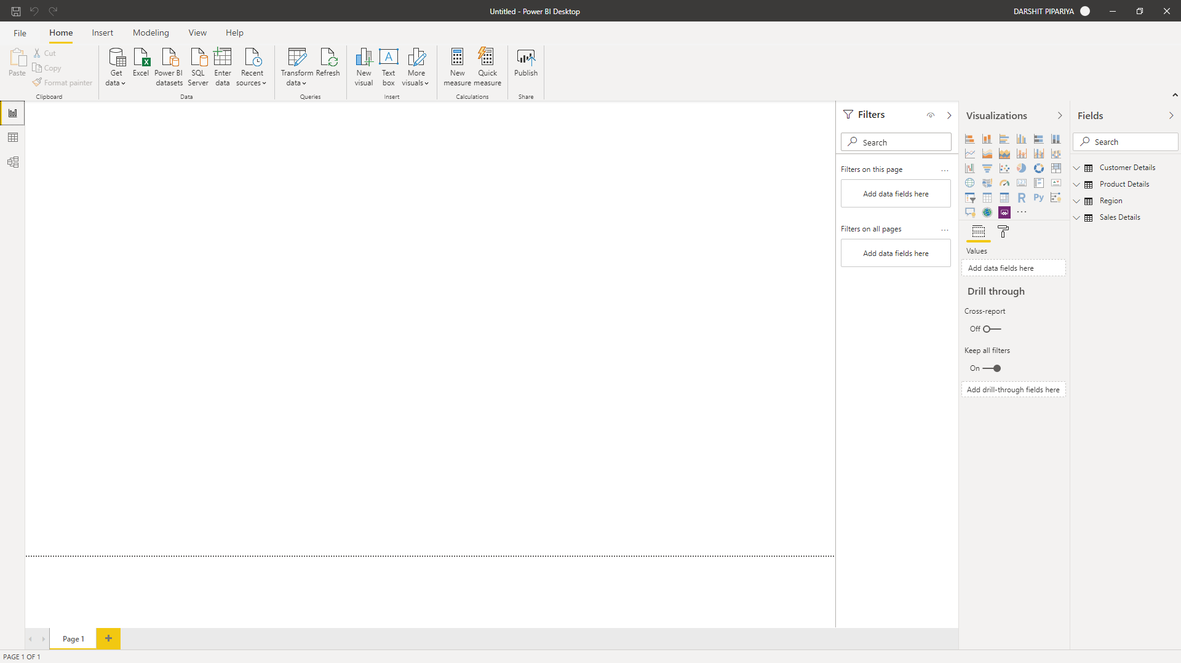

Report view

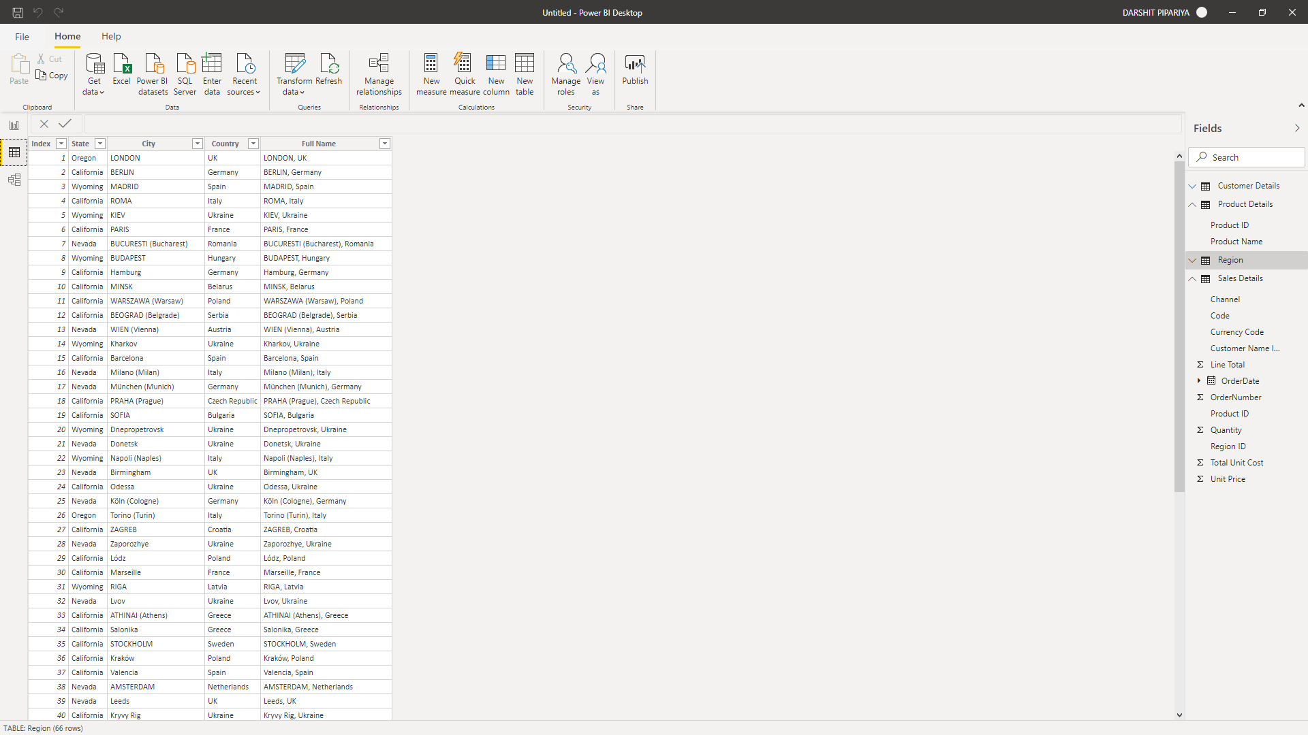

Data view

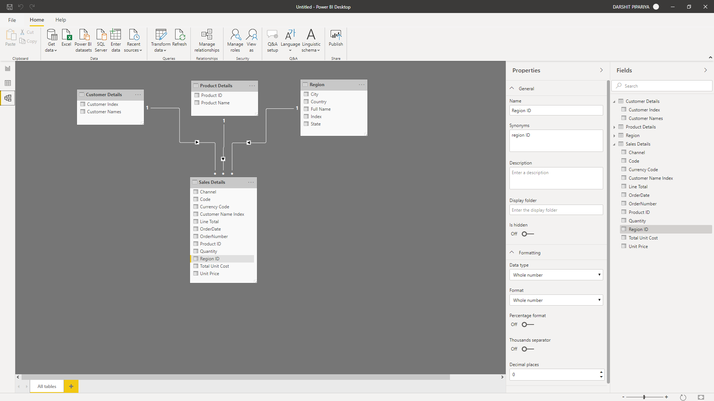

Model view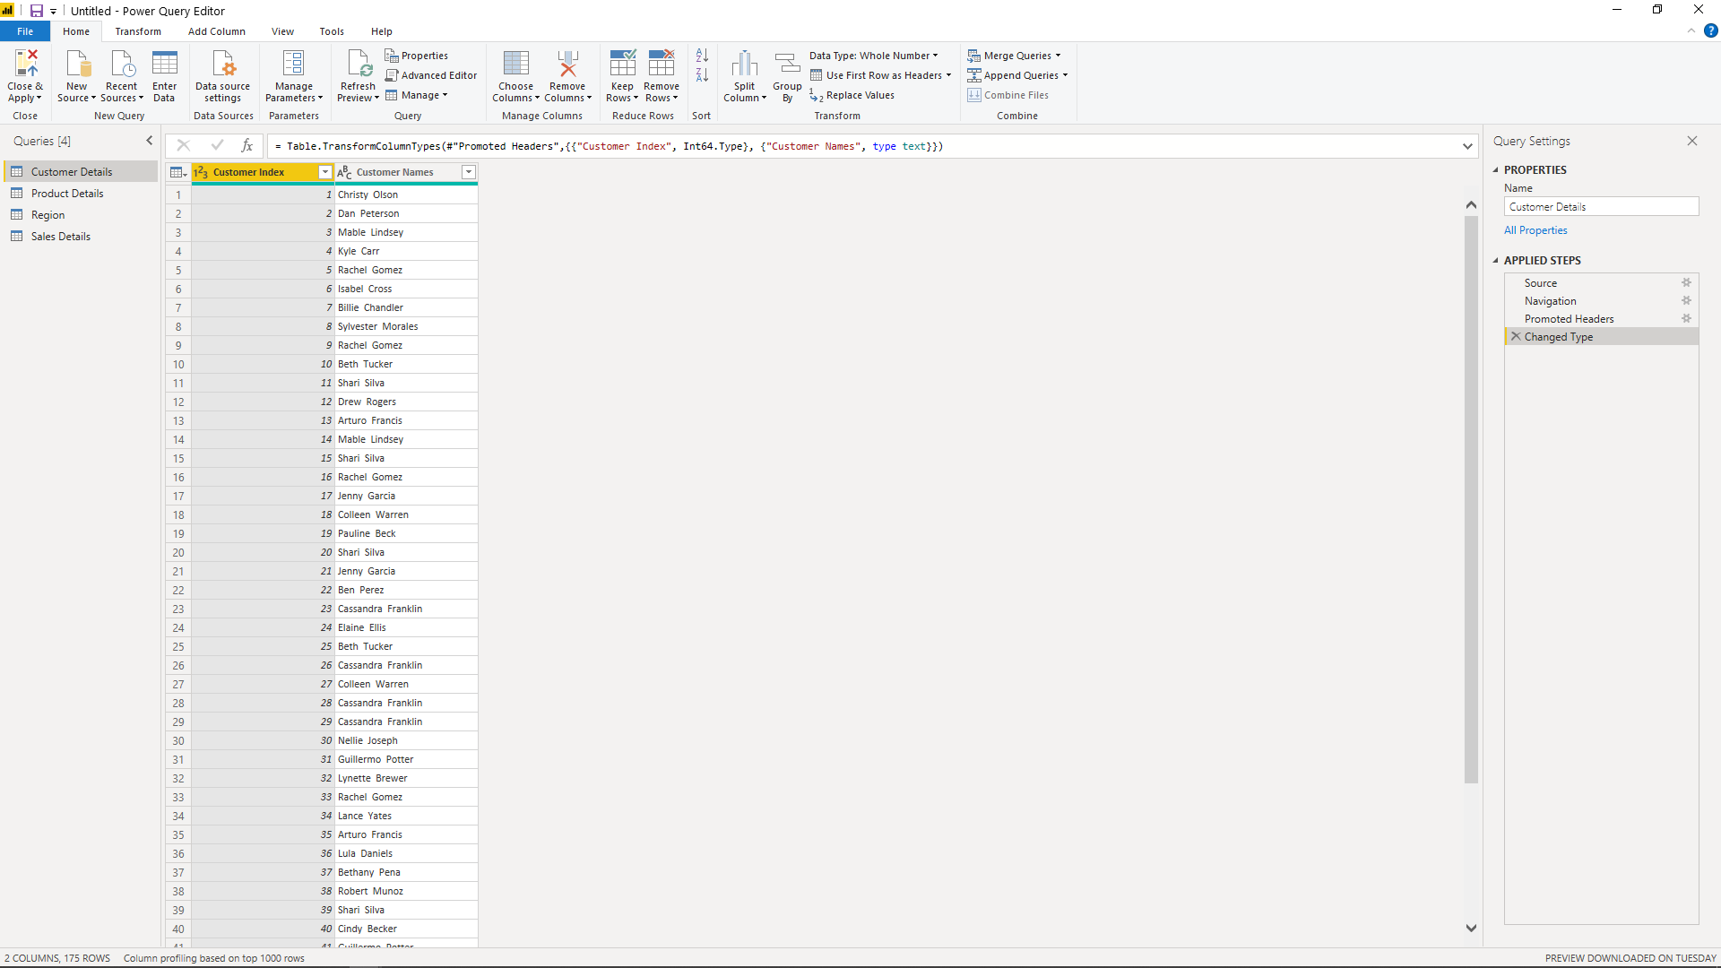

Query editor

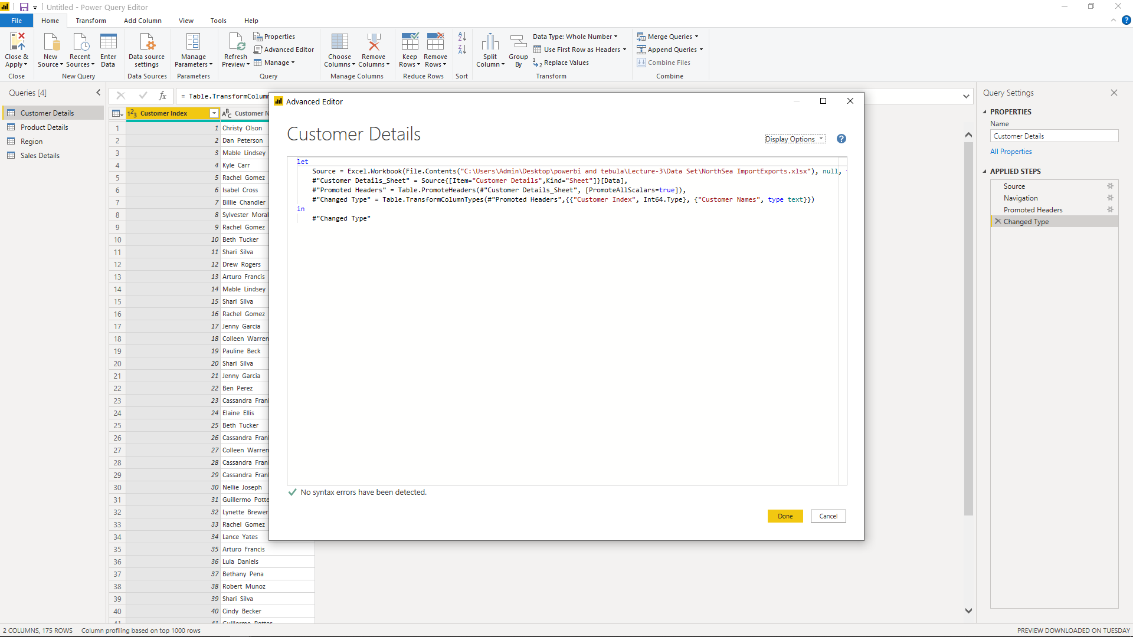

Advance query editor

# Questions

## 1 Price of Power BI Desktop, Power BI pro, Power BI premium .

### Power BI Desktop: Free

### Power BI pro : 660 ₹ Monthly price per user

### Power BI premium: 330190 ₹ Monthly price per dedicated cloud compute and storage resource with annual subscription